**International Management – Practical Class # 10**

**Case - OutSystems**

***PART I – The origin***

(Based on the case Doing Culture at OutSystems, from Nova SBE, 2014)

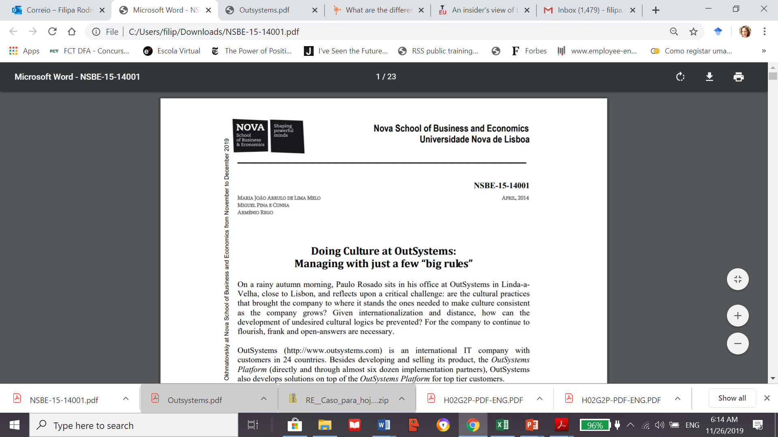

**OutSystems** (http://www.outsystems.com) is an international IT company with customers in 24 countries. Besides developing and selling its product, the OutSystems Platform (directly and through almost six dozen implementation partners), OutSystems also develops solutions on top of the OutSystems Platform for top tier customers.

Outsystems was founded in 2001 in the city of Linda-a-Velha (Portugal), by Paulo Rosado, a former employee of Oracle at Silicon Valley, together with Rui Pereira, Irene Montenegro, Lúcio Ferrão, and Rodrigo Coutinho. Paulo Rosado had met Rui Pereira and Irene Montenegro when he was still working in the USA, while Lúcio Ferrão and Rodrigo Coutinho joined the project when Paulo was working at Altitude Software, in Portugal.

The company expanded to foreign countries in 2004 and 2005, with the opening of the US and Dutch offices, respectively. While continuing to grow in its former locations, in April 2012 OutSystems opened offices in Brazil and South Africa, via partnerships with local entrepreneurs. In 2014, the company had offices in Australia, Benelux, Brazil, Japan, Portugal, Singapore, South Africa, UK, and the USA.

When Paulo Rosado started his career at Oracle (Silicon Valley), he had already decided to create a company of his own. In 2001, together with Rui Pereira, Irene Montenegro, Lúcio Ferrão, and Rodrigo Coutinho, he founded OutSystems. Not only did they decide that they wanted to create a company – they also wanted to create a great company to work for. In Paulo Rosado’s words:

“*I have always dreamed of a work environment that I wanted to go back to every morning. An environment full of smart people, where your mind is valued, and where you are rewarded for having cool ideas and doing a great job. Where people say what they mean and do what they say. And, above all, a place that is not boring. That is what we have at OutSystems*.”

Rui Pereira, vice-president of Solutions Delivery, had in common with Paulo the professional experience at Oracle in the US and shared with him the values and the work ethic of the American culture. Rui Pereira recalls OutSystems’ first year:

“*Each of us had to cover several areas; we were mainly focused on building something minimal to get funded and to get the first customers. While Rodrigo, Lúcio, and Irene were focused on building the prototype, Paulo and I were focused on getting funding and finding the first customer*.”

The funding necessary to build the OutSystems platform was obtained in September 2001 from a Dutch venture capital, NesBIC. In March 2002, the first version of the platform was deployed at Optimus, OutSystems’ first customer. António Melo, vice president of Engineering in 2012, joined the OutSystems team on the 2nd of January 2002. He had met the start-up team in mid-2001, when the company was “literally installed in a garage turned into small office rooms”, António remembers with a smile. When he joined the team, OutSystems had nine employees. He recalls his first year at OutSystems and the environment at that time:

“*OutSystems had amazing people: very creative, intelligent, and passionate about the product being built. The code base was growing like hell, turning lots of ideas into working code. It was very motivating to work in a team like that, but it was also scary, like an orchestra without a conductor; it actually worked due to people’s genius and passion. The most frantic period, for me, happened during the first year. The milestones were very aggressive, we were creating the first version of the platform and, at the same time, developing the first application on top of the platform for Optimus. It was a crucial period*.”

***Implementing the vision and purpose in the global arena***

**OutSystems was created as a product company from the very beginning**. Its product, the OutSystems Platform, was initially targeted at Mobile Telecommunication companies. With the Platform a mobile telco could empower its community of customers and developers to build their own mobile and web applications quickly and without having to install any software in their internal data centers. Today, the OutSystems Platform is a unified cloud or on-premises solution that addresses the full life-cycle of delivering and managing mobile and web business applications. It is currently used by companies in more than 22 industries. OutSystems’ vision and purpose — to solve the fundamental problem of IT inside any enterprise —have attracted the attention and praise, and the recognition of analysts, software industry experts, customers, and partners. This recognition (Exhibit 2) was accompanied by the company’s growth.

Although OutSystems has developed solutions for specific customers since its start-up, it was only in late 2005/early 2006, to accelerate adoption of the Platform by the customer base, that it decided to grow the services area (known internally as Solutions Delivery) on a larger scale and in a more professional manner. Rui Pereira, responsible for the services area explained what happened prior to March 2006:

“*The services were always responsible for a large part of our revenue. At first the services area worked pretty much ad hoc, with a bunch of very competent guys working to solve clients’ technical and business problems. In 2006, we realized that we had to move from an ad hoc services organization to a professional services organization, and we hired one person just to manage that department. We changed to an organization where we have efficient processes, process innovation, and human resource management, making the business efficient from both a process and a human resource allocation perspective*.”

The international expansion started after the first version of the platform was launched. To leverage the fact that OutSystems was partially owned by a Dutch VC, the board decided to expand to the Netherlands. Carlos Alves, current vice president of International Operations, explains:

“*It is not that the VC has brought us a significant sales pipeline. But considering that we had to present ourselves as a foreign company, in the Netherlands we could at least state that we had a Dutch shareholder. That helped introduce us to customers. Out of that simple fact, we started building relationships, and we gathered three customers before opening local operations there*.”

The decision to expand to the US was based on the excellent market conditions and on cultural affinity. The affinity came from the founders’ experience — both Paulo Rosado and Rui Pereira had worked in the US. The evaluation of the market conditions was based on US growth and IT expenditures, which remain the largest market in the world. Furthermore, in theory, it would be easier to address the American market rather than the European, given that it has just one language and similar legislation among the states. Both expansions started with sales executed by the management team through travelling to the target locations. This was followed by setting up the first two or three clients, and only afterwards opening local operations. Carlos explained the lessons learned from the first foreign experiences:

“*We did not believe that we were going to send Portuguese people trained in the main office all over the world and that we were going to be successful, because we were going to miss the local culture’s capabilities to interrelate and drive relationships at a high level. Moreover, being a new company and being unknown makes it very difficult to attract talent. We have made mistakes in the past: we sent Portuguese people to the US, and they did an excellent job. But, alone, they were not able to be as successful as we needed. In the Netherlands, we did it the other way around: we started by hiring a local country manager, but because the core values of the OutSystems culture were not there, it too didn’t work*.”

Currently, the Dutch office is supervised from Portugal and staffed with local Dutch employees. In the US, the country manager is an American, and there are both American and Portuguese members among the staff. Although present in several countries, the majority of OutSystems employees are still Portuguese. Most of them are software engineers, and the mean age is 35 years old. By 2013, OutSystems had reached 214 employees and its growth has not stopped. Its workforce is distributed among delivery, engineering, marketing, and sales departments. The product engineering function does not exist outside Portugal, but every location has all the departments necessary for field operations. This includes solutions delivery and field marketing.

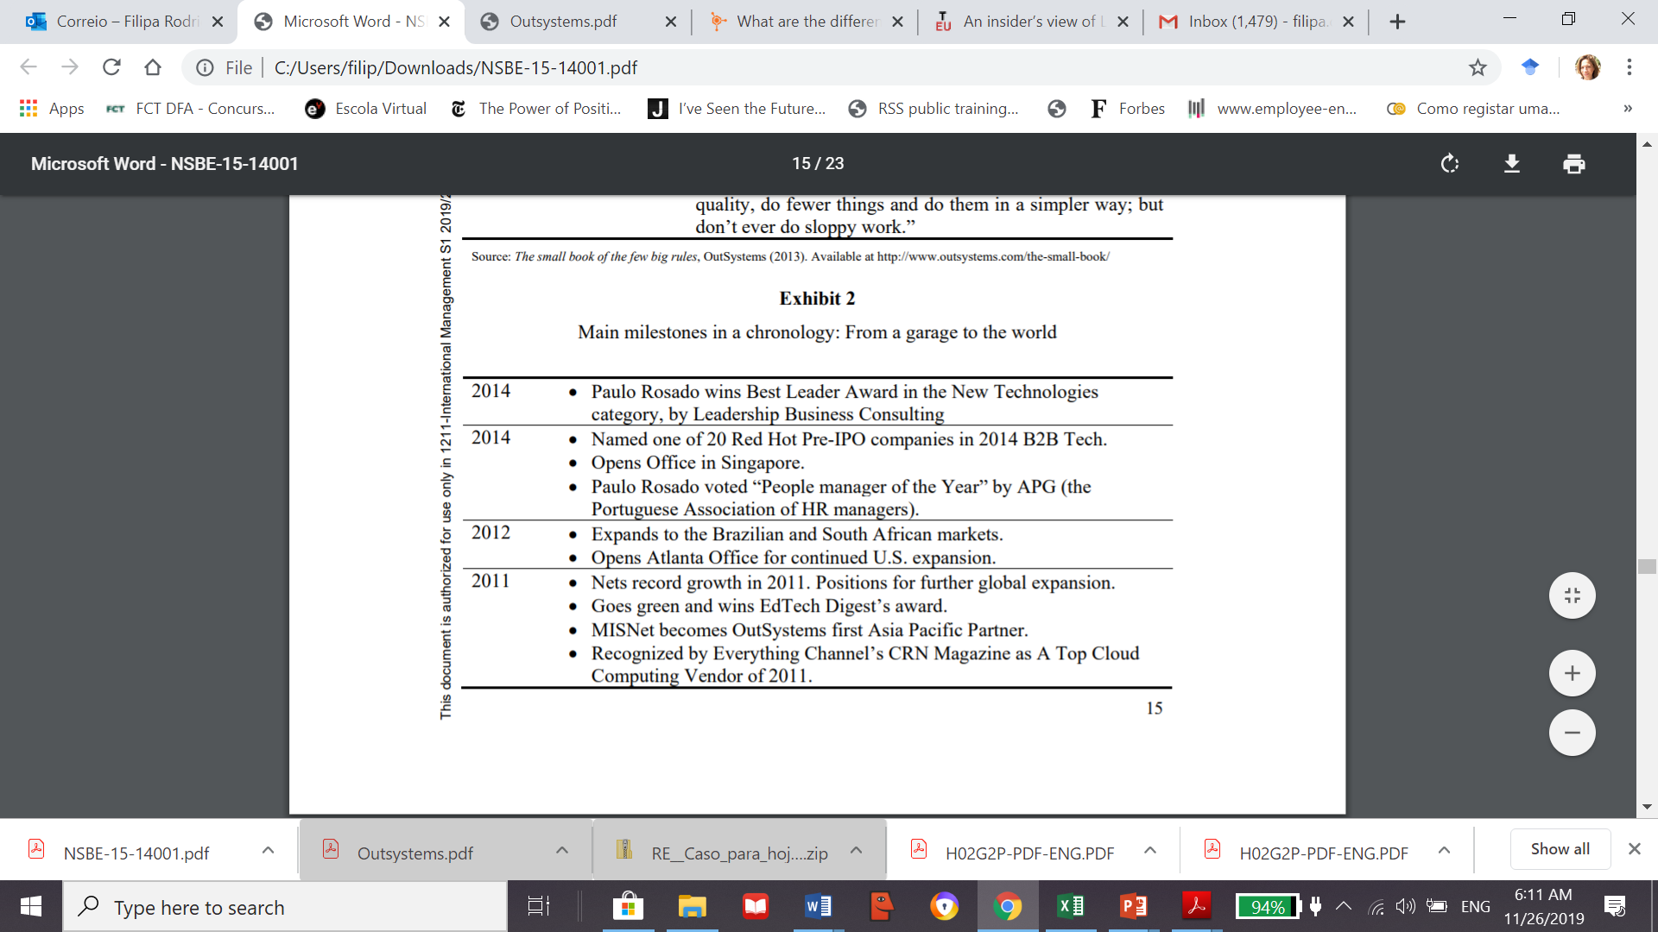

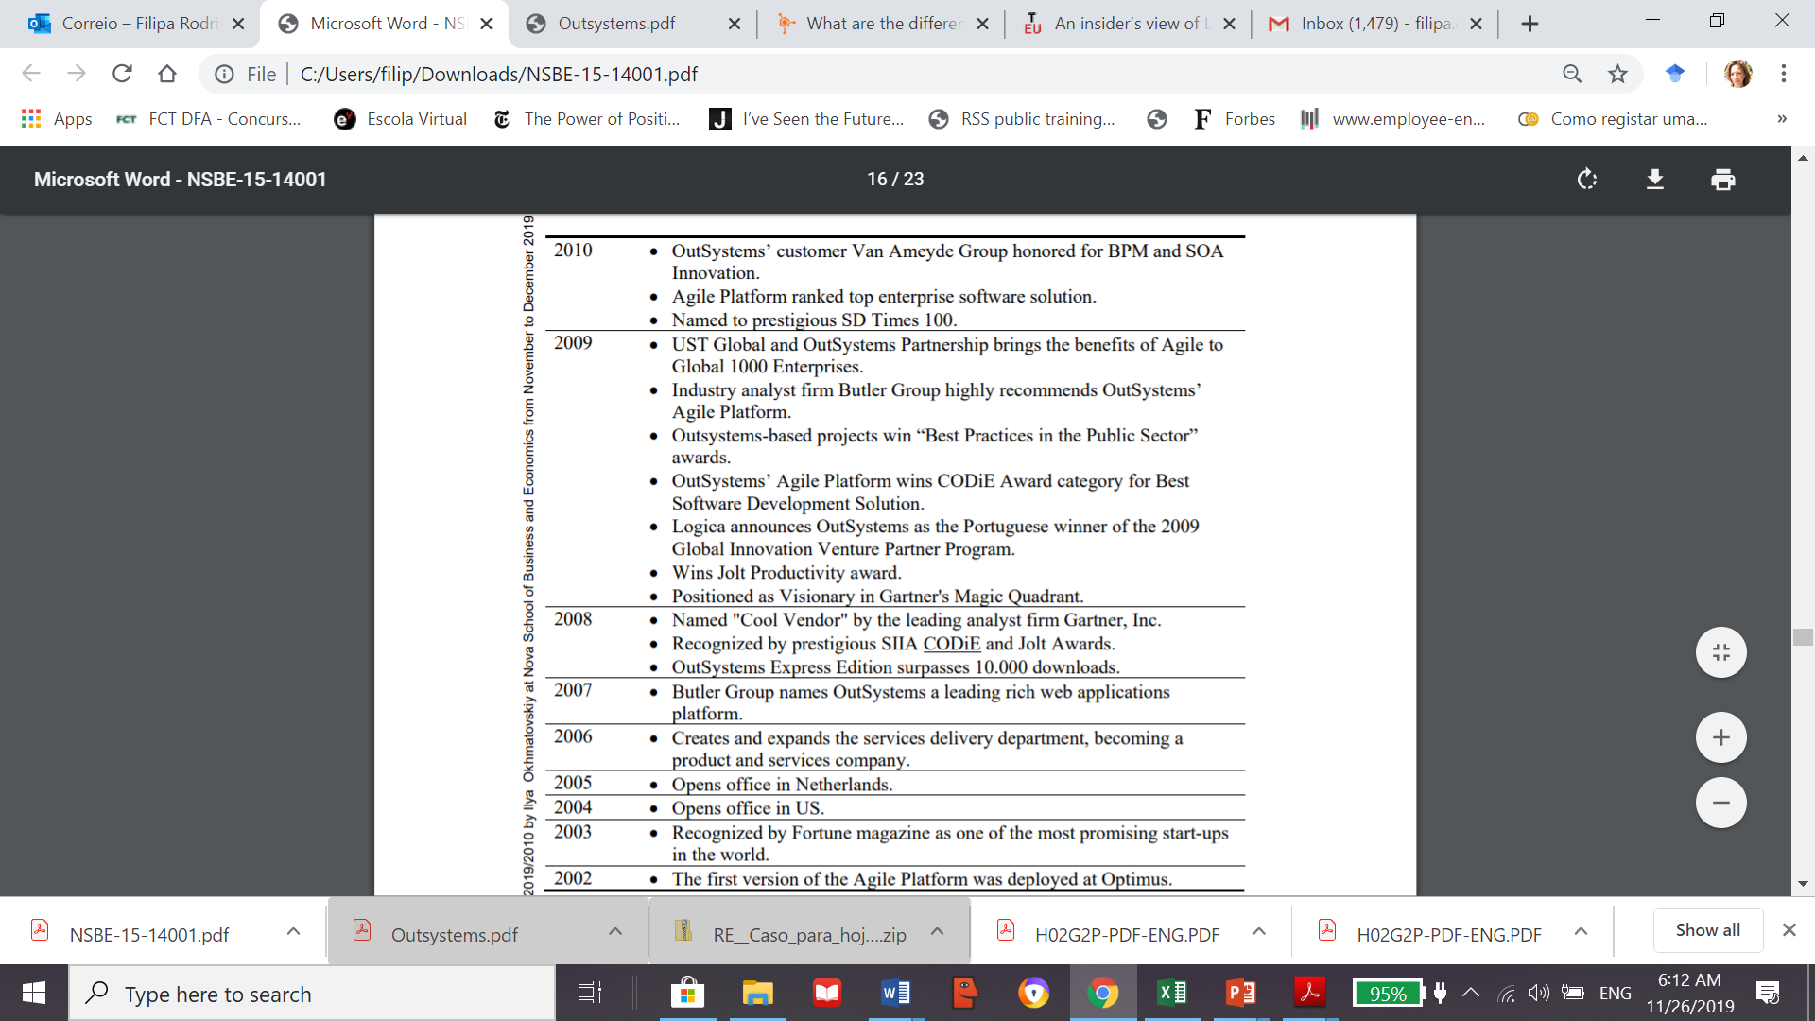

***PART II – On their way to unicorn status***

(based on <https://www.forbes.com/sites/forbesinternational/2018/07/13/is-outsystems-portugals-latest-unicorn/#7c65d28c3633>)

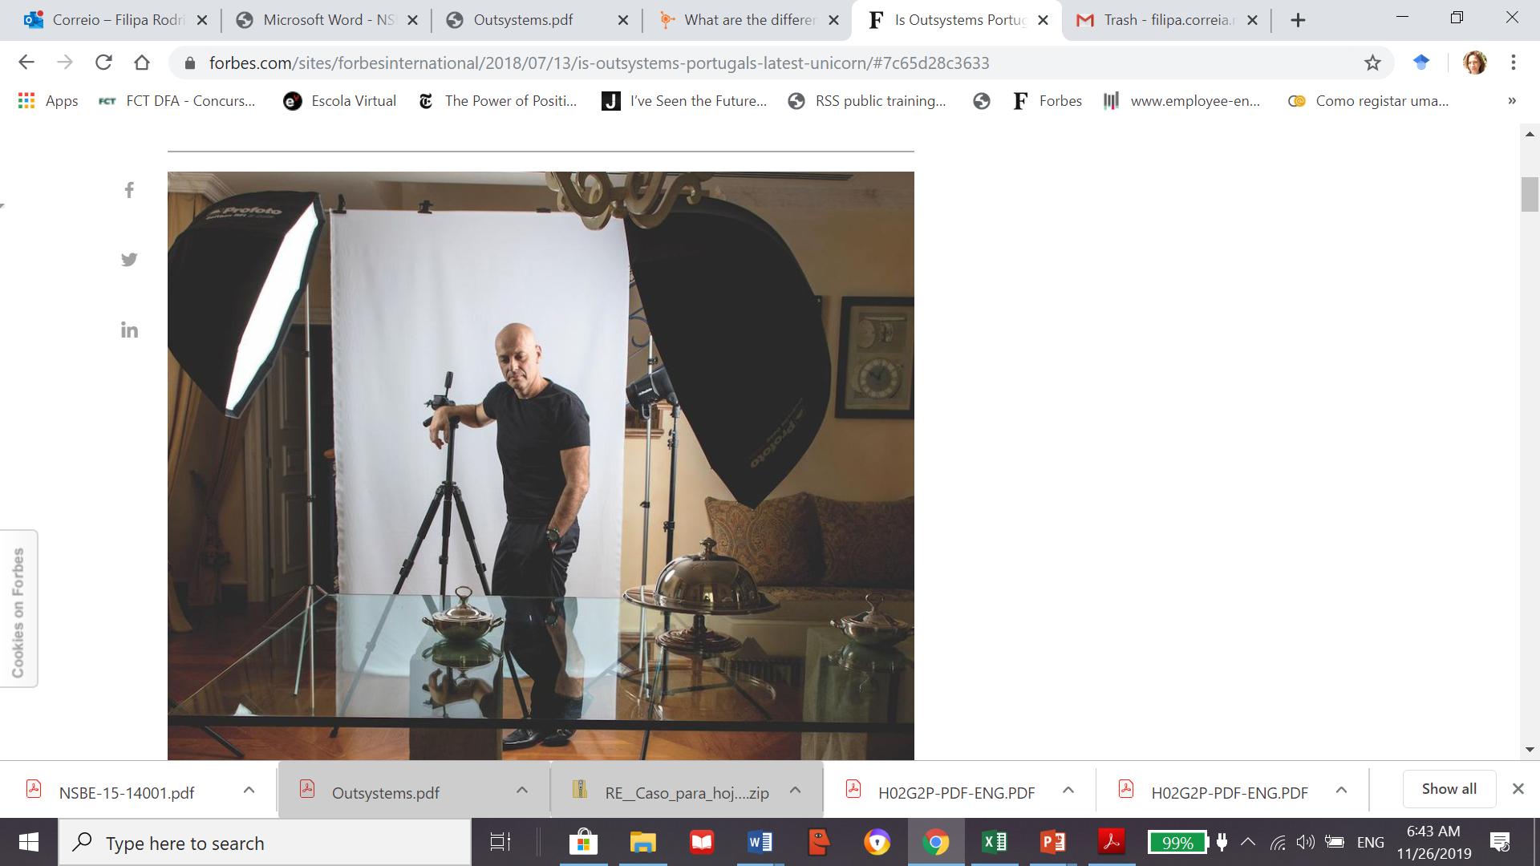

**There are those who think “outside of the box” and there are those who think outside of the system that contains the box. Paulo Rosado of Outsystems is one of the rare later types.**

When Paulo Rosado moved to the United States in the mid-1990s on a Fulbright Master’s Degree grant to study computational science at Stanford University, the future plans of the recent IT engineering graduate from Lisbon’s Nova University were focused on a career in academia. But academia was set aside, as the airs of Silicon Valley proved too sweet. “I remember perfectly the day when I changed what I wanted,” says Rosado. “It was four in the morning, I was at a workstation – a type of university co-working facility – finishing off a project, myself and four Chinese students, when suddenly it seemed as though a lightning bolt flashed through my head and I thought: this is not the life that I want.” That night, a potentially great professor was lost, but a fine Portuguese business manager was born.

Today, 17 years after founding the Portugal-based enterprise software firm Outsystems, Rosado’s enterprise is believed to have the capacity to achieve the scale of huge companies like SAP or Oracle. Outsystems is the first low-code platform for application development. Shamit Mehta, a lead analyst at the risk capital fund Guidepost Growth Equity, which invested around $55 million in Outsystems in 2016, told FORBES that “the ingredients are all there.” But this is just the beginning, he says. Mehta estimates that the market for “low-code” software development platforms, the field in which Outsystems operates, will amount to 22 billion Euros in 2022. This reality places the company—the current market leader and supplier of the best product according to the prestigious technological consultancies Gartner and Forrester—on the verge of becoming the next Portuguese unicorn.

Recently, Outsystems announced it has raised $360 million in investment capital from KKR and Goldman Sachs. The funding values the company at more than $1 billion. The money will be used to accelerate business expansion and for R&D in software automation.

**In 2001**, due to hangover from the North American technology bubble burst, raising capital was not expected to be an easy task but, as the popular saying goes, “fortune favors the brave.” One month after 9/11, Rosado raised one million euros. “We got in through a crack in the door. Six months later, the market closed,” he said while laughing, highlighting that you also need to be lucky. In the case of Outsystems, this luck came after more than 40 pitches Rosado made to potential investors, at the end of which he would often receive responses such as “impossible” or “madness.”

During the company’s last “Sales Kickoff” at the Hotel Grande Real Villa Itália, in Cascais, at the beginning of February—an event that brought together more than 200 Outsystems employees for a week—Carlos Alves, Rosado’s right-hand man and ‘chief people officer’ at the company, recalls an episode that well reflects Rosado’s determination. “*In 2004, the two of us went off to make a pitch to one of the top analysts at a company in the market. At the end, the analyst told us that Outsystems would not survive more than three years because the market would get eaten up by IBM and the other giants. Paulo did not spare his words in response and left the meeting absolutely certain that the guy was wrong and that we would prevail*.”

With a product ready for launch, Outsystems designed a business model that started out by targeting the telecommunications sector. It secured its first client, the Portuguese telecommunications company Optimus, which would be crucial to the survival of the firm, before landing the Spanish operator Telefónica, and then another operator in the Netherlands. However, the sector then suddenly went into recession due to high prices for 3G licenses and the market dried up. The needs of the hour required ingeniousness in the product and financial model.

**If your business is selling yogurt**, you know there is going to be demand to a greater or lesser extent. However, if your field is electric cars, the assumption of demand changes. “*Now there is demand for electric vehicles, if a manufacturer had tried to move into the market at the beginning of the century, then they would have had serious difficulties surviving*,” explained Rosado. When reaching a market with a very different product with no demand, companies go through a phase often termed “the evangelic sales phase,” in which company leadership must attempt change and create opinions in people about their product. “*In these cases, the idea is to get to market two or three years before demand rockets. We arrived twelve years before*,” Rosado exclaimed before confessing that over this period Outsystems twice teetered on the verge of bankruptcy.

One of the darkest days, with collapse looming, took place just shortly after its foundation. The business model planned for initial fund raising of one million Euros followed by another round raising three million Euros 18 months later. However, the states of both of its telecommunications clients, and of the capital markets, were not at all favorable. And this is where the importance of Optimus comes in. Due to its agility, the Sonae group telecommunications operator had begun using the platform to come up with internal applications. “*Let’s sell this to companies as a solution for making applications*,” thought Rosado. And thus it happened. Outsystems won over the toll-road company Brisa, and then ANA – Aeroportos de Portugal – two large companies that were then followed by 20 more clients that enabled Outsystems to break even. “*We spent three years spinning out that one million Euros*,” says Rosado. “Nobody knew but we were practically out of cash in the bank. That was the time when I lost all of my hair.”

Eleven years ago, the way companies worked on their information technology systems was the same as they’d done at the beginning of the century when Outsystems was founded. Companies would purchase software packages and then contract large consultancies such as Deloitte or Accenture, for example, to develop a tailored application that would change on a monthly basis in keeping with the dynamics of the business. “*One thing was being able to get a market niche and another was changing the functional model in a gigantic industry*,” said Rodrigues. Then Outsystems risked everything by changing the way it monetized its business, differentiating itself from competitors.

In 2011, with business still far from any great leap forward, Rosado made the decision to change the pricing model, giving up on the sale of open-ended licenses to begin selling software subscriptions instead. With this change, that he confessed was done “in an act of madness,” the company sought to boost experimentation with the platform and thus gain more clients. However, this would lead to a sharp downturn in earnings as the value of a subscription was far lower than a lifelong license.

Rosado was thus expecting to lose some revenue but he did not predict anything quite as dramatic as what happened. “We thought that we would lower our turnover by three times but instead the drop was six times,” he said. Time, however, would justify the decision. Today, practically every company in every sector has switched from one-off license sales to annual subscription models. In the case of Outsystems, the company went from employing 134 staff members in 2011 to over 600. “Within the space of four years we made the shift from a traditional company to a cloud company,” says Rosado.

**Despite having** reached the 100 million euros revenue benchmark, Outsystems operates in a market with a potential value of 22 billion euros. Moving forward, one challenge may be resisting a potential takeover bid. With the company having already attracted clients such as Toyota Motors, Siemens and the insurer Axa, and gaining market share in the United States, it is natural and legitimate for software giants to feel threatened. Rosado told FORBES that this he has no plans to make such an exit. “Money was never my objective,” he says.

In the last six years, Outsystems has recorded soaring rates of growth with turnover spiking by an annual average of 41%. Last year revenue was up by 63%, surpassing 100 million Euros. Currently, over 80% of this turnover comes from outside Portugal with a particular emphasis on the United States – in 2010, the Portuguese market accounted for 53% of company income.